# Team Members: Shraman Basyal, John Slack, Shane Deng, Jonny Howard

# 1. Project Title.

Predicting the value of Football/Soccer players from their FIFA 2019 statistics.

# 2. Description of data source and web link(s).

Data includes players attributes from the 2019 edition FIFA video game.

Web link to data:[**https://www.kaggle.com/karangadiya/fifa19**](https://www.kaggle.com/karangadiya/fifa19)

# 3. # of records & # of attributes with description of each attribute.

18,207 records, 47 attributes chosen from dataset

|  |  |  |  |  |  |  |
| --- | --- | --- | --- | --- | --- | --- |
| **Feature Name** | **Example Data** | **Feature Type** | **Data Type 1** | **Data Type 2** | **Note** | **Unit** |
| Age | 31 | Objective Feature | int | Numerical |  | Years |
| Nationality | Argentina | Objective Feature | str | Categorical | Option to encode or drop | N/A |
| Club | FC Barcelona | Objective Feature | str | Categorical | Option to encode or drop | N/A |
| Value | €110.5M | Target Variable | str | Numerical | Need to reformat to int from str | Euros |
| Preferred Foot | Left | Objective Feature | str | Categorical |  | Categorical |
| International Reputation | 5 | Subjective Variable | int | Numerical | Could be treated as ordinal. Higher is better | Rating 1-5 |
| Weak Foot | 4 | Subjective Variable | int | Numerical | Could be treated as ordinal. Higher is better | Rating 1-5 |
| Skill Moves | 4 | Subjective Variable | int | Numerical | Could be treated as ordinal. Higher is better | Rating 1-5 |
| Work Rate | Medium/ Medium | Subjective Variable | str | Ordinal | Convert to attacking/defensive workrate |  |
| Position | RF | Objective Feature | str | Categorical |  |  |
| Contract Valid Until | 2021 | Objective Feature | int | Numerical | Covert to Years left on contract | Year |
| Height | 5'7 | Objective Feature | str | Numerical | Convert to inches/int | ft/inches |
| Weight | 159lbs | Objective Feature | str | Numerical | Convert to int | lbs |
| Crossing | 84 | Subjective Variable | int | Numerical |  | Rating /100 |
| Finishing | 95 | Subjective Variable | int | Numerical |  | Rating /100 |
| HeadingAccuracy | 70 | Subjective Variable | int | Numerical |  | Rating /100 |
| ShortPassing | 90 | Subjective Variable | int | Numerical |  | Rating /100 |
| Volleys | 86 | Subjective Variable | int | Numerical |  | Rating /100 |
| Dribbling | 97 | Subjective Variable | int | Numerical |  | Rating /100 |
| Curve | 93 | Subjective Variable | int | Numerical |  | Rating /100 |
| FKAccuracy | 94 | Subjective Variable | int | Numerical | FK = Free Kick | Rating /100 |
| LongPassing | 87 | Subjective Variable | int | Numerical |  | Rating /100 |
| BallControl | 96 | Subjective Variable | int | Numerical |  | Rating /100 |
| Acceleration | 91 | Subjective Variable | int | Numerical |  | Rating /100 |
| SprintSpeed | 86 | Subjective Variable | int | Numerical |  | Rating /100 |
| Agility | 91 | Subjective Variable | int | Numerical |  | Rating /100 |
| Reactions | 95 | Subjective Variable | int | Numerical |  | Rating /100 |
| Balance | 95 | Subjective Variable | int | Numerical |  | Rating /100 |
| ShotPower | 85 | Subjective Variable | int | Numerical |  | Rating /100 |
| Jumping | 68 | Subjective Variable | int | Numerical |  | Rating /100 |
| Stamina | 72 | Subjective Variable | int | Numerical |  | Rating /100 |
| Strength | 59 | Subjective Variable | int | Numerical |  | Rating /100 |
| LongShots | 94 | Subjective Variable | int | Numerical |  | Rating /100 |
| Aggression | 48 | Subjective Variable | int | Numerical |  | Rating /100 |
| Interceptions | 22 | Subjective Variable | int | Numerical |  | Rating /100 |
| Positioning | 94 | Subjective Variable | int | Numerical |  | Rating /100 |
| Vision | 94 | Subjective Variable | int | Numerical |  | Rating /100 |
| Penalties | 75 | Subjective Variable | int | Numerical |  | Rating /100 |
| Composure | 96 | Subjective Variable | int | Numerical |  | Rating /100 |
| Marking | 33 | Subjective Variable | int | Numerical |  | Rating /100 |
| StandingTackle | 28 | Subjective Variable | int | Numerical |  | Rating /100 |
| SlidingTackle | 26 | Subjective Variable | int | Numerical |  | Rating /100 |
| GKDiving | 6 | Subjective Variable | int | Numerical | GK = Goalkeeper | Rating /100 |
| GKHandling | 11 | Subjective Variable | int | Numerical | GK = Goalkeeper | Rating /100 |
| GKKicking | 15 | Subjective Variable | int | Numerical | GK = Goalkeeper | Rating /100 |
| GKPositioning | 14 | Subjective Variable | int | Numerical | GK = Goalkeeper | Rating /100 |
| GKReflexes | 8 | Subjective Variable | int | Numerical | GK = Goalkeeper | Rating /100 |

# 4. Some general statistics of the dataset.

|  |  |  |  |  |  |  |  |  |  |  |  |
| --- | --- | --- | --- | --- | --- | --- | --- | --- | --- | --- | --- |
|  | **count** | **unique** | **top** | **freq** | **mean** | **std** | **min** | **25%** | **50%** | **75%** | **max** |
| **Age** | 18207 |  |  |  | 25.12 | 4.67 | 16 | 21 | 25 | 28 | 45 |
| **Nationality** | 18207 | 164 | England | 1662 |  |  |  |  |  |  |  |
| **Club** | 17966 | 651 | FC Barcelona | 33 |  |  |  |  |  |  |  |
| **Preferred Foot** | 18159 | 2 | Right | 13948 |  |  |  |  |  |  |  |
| **International Reputation** | 18159 |  |  |  | 1.11 | 0.39 | 1 | 1 | 1 | 1 | 5 |
| **Weak Foot** | 18159 |  |  |  | 2.95 | 0.66 | 1 | 3 | 3 | 3 | 5 |
| **Skill Moves** | 18159 |  |  |  | 2.36 | 0.76 | 1 | 2 | 2 | 3 | 5 |
| **Work Rate** | 18159 | 9 | Medium/ Medium | 9810 |  |  |  |  |  |  |  |
| **Position** | 18147 | 27 | ST | 2152 |  |  |  |  |  |  |  |
| **Contract Valid Until** | 17918 | 36 | 2019 | 4819 |  |  |  |  |  |  |  |
| **Height** | 18159 | 21 | 6'0 | 2881 |  |  |  |  |  |  |  |
| **Weight** | 18159 | 57 | 165lbs | 1483 |  |  |  |  |  |  |  |
| **Crossing** | 18159 |  |  |  | 49.73 | 18.36 | 5 | 38 | 54 | 64 | 93 |
| **Finishing** | 18159 |  |  |  | 45.55 | 19.53 | 2 | 30 | 49 | 62 | 95 |
| **HeadingAccuracy** | 18159 |  |  |  | 52.30 | 17.38 | 4 | 44 | 56 | 64 | 94 |
| **ShortPassing** | 18159 |  |  |  | 58.69 | 14.70 | 7 | 54 | 62 | 68 | 93 |
| **Volleys** | 18159 |  |  |  | 42.91 | 17.69 | 4 | 30 | 44 | 57 | 90 |
| **Dribbling** | 18159 |  |  |  | 55.37 | 18.91 | 4 | 49 | 61 | 68 | 97 |
| **Curve** | 18159 |  |  |  | 47.17 | 18.40 | 6 | 34 | 48 | 62 | 94 |
| **FKAccuracy** | 18159 |  |  |  | 42.86 | 17.48 | 3 | 31 | 41 | 57 | 94 |
| **LongPassing** | 18159 |  |  |  | 52.71 | 15.33 | 9 | 43 | 56 | 64 | 93 |
| **BallControl** | 18159 |  |  |  | 58.37 | 16.69 | 5 | 54 | 63 | 69 | 96 |
| **Acceleration** | 18159 |  |  |  | 64.61 | 14.93 | 12 | 57 | 67 | 75 | 97 |
| **SprintSpeed** | 18159 |  |  |  | 64.73 | 14.65 | 12 | 57 | 67 | 75 | 96 |
| **Agility** | 18159 |  |  |  | 63.50 | 14.77 | 14 | 55 | 66 | 74 | 96 |
| **Reactions** | 18159 |  |  |  | 61.84 | 9.01 | 21 | 56 | 62 | 68 | 96 |
| **Balance** | 18159 |  |  |  | 63.97 | 14.14 | 16 | 56 | 66 | 74 | 96 |
| **ShotPower** | 18159 |  |  |  | 55.46 | 17.24 | 2 | 45 | 59 | 68 | 95 |
| **Jumping** | 18159 |  |  |  | 65.09 | 11.82 | 15 | 58 | 66 | 73 | 95 |
| **Stamina** | 18159 |  |  |  | 63.22 | 15.89 | 12 | 56 | 66 | 74 | 96 |
| **Strength** | 18159 |  |  |  | 65.31 | 12.56 | 17 | 58 | 67 | 74 | 97 |
| **LongShots** | 18159 |  |  |  | 47.11 | 19.26 | 3 | 33 | 51 | 62 | 94 |
| **Aggression** | 18159 |  |  |  | 55.87 | 17.37 | 11 | 44 | 59 | 69 | 95 |
| **Interceptions** | 18159 |  |  |  | 46.70 | 20.70 | 3 | 26 | 52 | 64 | 92 |
| **Positioning** | 18159 |  |  |  | 49.96 | 19.53 | 2 | 38 | 55 | 64 | 95 |
| **Vision** | 18159 |  |  |  | 53.40 | 14.15 | 10 | 44 | 55 | 64 | 94 |
| **Penalties** | 18159 |  |  |  | 48.55 | 15.70 | 5 | 39 | 49 | 60 | 92 |
| **Composure** | 18159 |  |  |  | 58.65 | 11.44 | 3 | 51 | 60 | 67 | 96 |
| **Marking** | 18159 |  |  |  | 47.28 | 19.90 | 3 | 30 | 53 | 64 | 94 |
| **StandingTackle** | 18159 |  |  |  | 47.70 | 21.66 | 2 | 27 | 55 | 66 | 93 |
| **SlidingTackle** | 18159 |  |  |  | 45.66 | 21.29 | 3 | 24 | 52 | 64 | 91 |
| **GKDiving** | 18159 |  |  |  | 16.62 | 17.70 | 1 | 8 | 11 | 14 | 90 |
| **GKHandling** | 18159 |  |  |  | 16.39 | 16.91 | 1 | 8 | 11 | 14 | 92 |
| **GKKicking** | 18159 |  |  |  | 16.23 | 16.50 | 1 | 8 | 11 | 14 | 91 |
| **GKPositioning** | 18159 |  |  |  | 16.39 | 17.03 | 1 | 8 | 11 | 14 | 90 |
| **GKReflexes** | 18159 |  |  |  | 16.71 | 17.96 | 1 | 8 | 11 | 14 | 94 |
| **Value** | 18207 | 217 | €1.1M | 431 |  |  |  |  |  |  |  |

# 5. Tools / methods your team (plan to) use in your study.

We will utilize Python and MATLAB to analyze data and build the model. We will use an ensemble method of combination of linear regression and SVM models for 4 categories of player that we will define: Goalkeeper, Defender, Midfielder, Attacker.

# 6. Detail description of what problems/questions your team plans to predict / study.

Question 1. How can we classify player position (4 categories of player that we will define: Goalkeeper, Defender, Midfielder, Attacker) based on their statistics?

We are planning to utilize SVM model to predict the class/position of the player.

Question 2. How can we predict players’ value based on statistics?

We will be doing a linear regression model for each position group from question 1 to predict the player’s value.

7. Presentation Summary

Initially our goal was to predict the player value and correctly predict the players’ position by utilizing an ensemble of linear regression to determine player value and SVM RBF to determine player position.

Data Cleansing

We began with a large amount of data cleansing and modification.

There were conversions of units, removal of special characters, and others.

Null values and zero’d values were dropped from the dataset, losing <1% of total data.

Data Preparation

We aggregated a number of categorical variables, amounting in a 94% reduction in dummy variables.

We standardized the data, and elected to treat some numeric values as ordinal categorical based on their extreme left skew.

This still left us with 111 variables though, so we were concerned about our high dimensionality.

SVM RBF

Our classification model to determine player positions performed really poorly

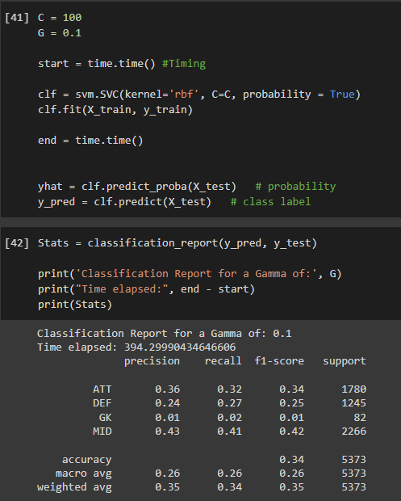

We suspected this was due to unbalanced data and used SMOTE to balance the data, but this produced a very minor improvement. It’s likely we were using the wrong tool for the job, as SVM RBF doesn’t handle categorical variables as it makes it difficult to determine distance between points. In addition to this, it was very slow.

Linear Regression Models

We used an ensemble of Linear Regression models to determine each position’s value. 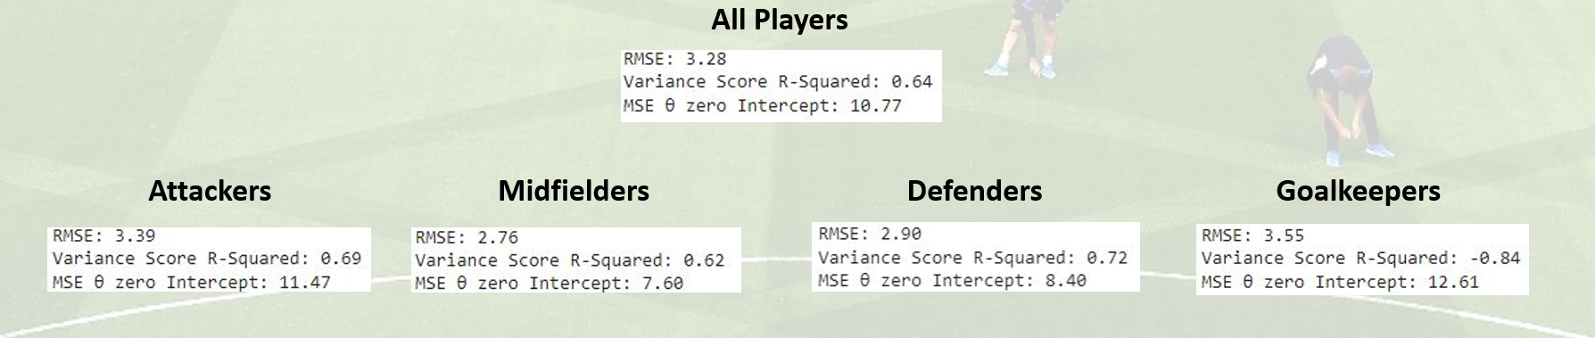

This demonstrated an improvement over the initial model, but presented issues with Goalkeepers, our minority class.

Having a high dimensional dataset, we used Lasso Regularization techniques in Matlab to simplify our models

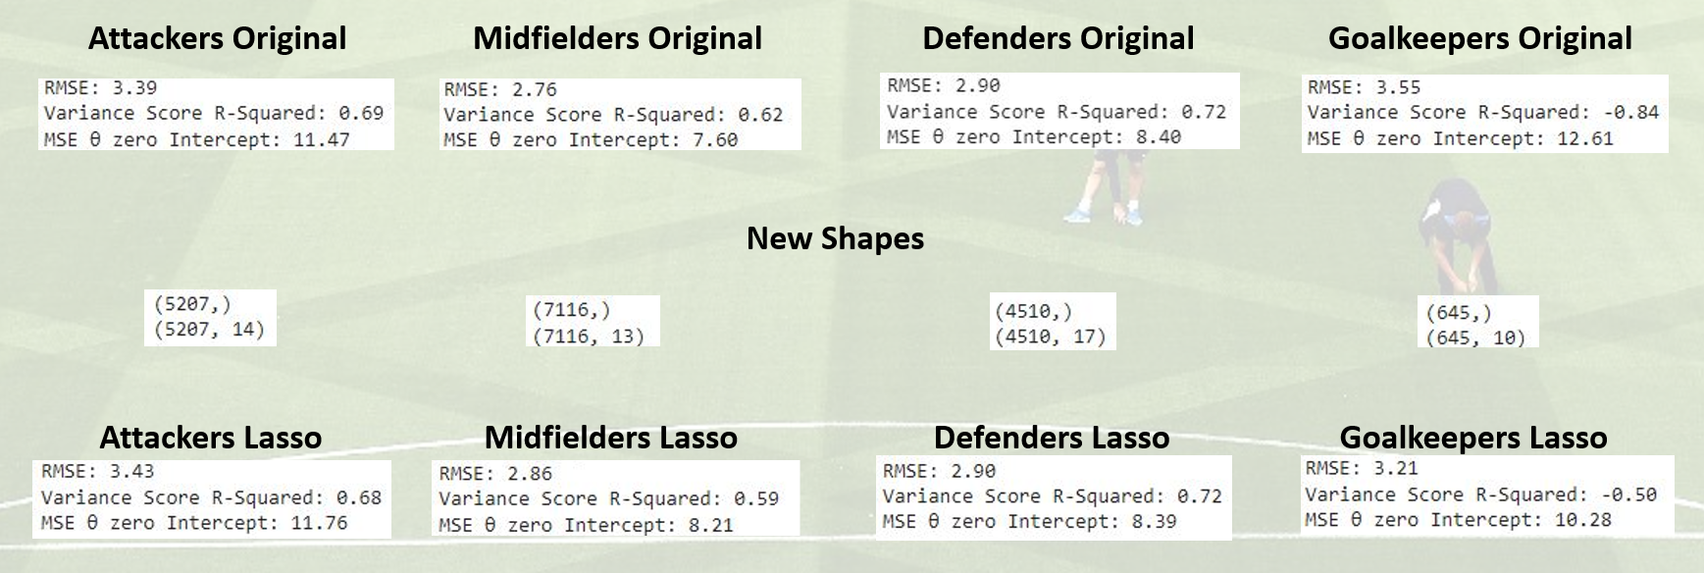

Conclusions and Next Steps

However, as we progressed, we realized that we did a linear regression on a non-linear problem, which did not provide desired solution. We also learned that SVM RBF may not be a good fit for our problem. The large amount of the dummy variables in our data may contributed to the low performing SVM models.

We determined that decision tree or one-class classification may work better for our problem.

*We revisited the code, examined our data preparation, and added decision tree and one-class classification models to our code.*